GENETIC ALGORITHM TO GENERATE A PLANE

**Plane character generator**

The assignment to generate a character using Genetic Algorithm, is used to create a 3D plane that takes a run to attain a flying speed. The GA is employed to power the plane with required engine force and the fuel needed before the takeoff. As more engines are attached, the weight increases, making the plane bulky. Thus, attaching the engines randomly won’t work. This is a Unity3D sample, build using C# and UnityScript. It is essential to note that you can use the mouse to also add obstacles and make it difficult for the plane to fly.

Let us define a few terms before we understand how it is used.

**Chromosome:** This is the most basic unit of genetic algorithm, used to represent data that will be manipulated using the laws of GA. The chromosome may be used to represent an entity, which is modified over time and generations to produce a fit offspring. All the chromosome together will represent the population for the GA. All the GA operations are applied on the population, thus, on each chromosome specifically.

For the above sample, we are using the following as a chromosome. 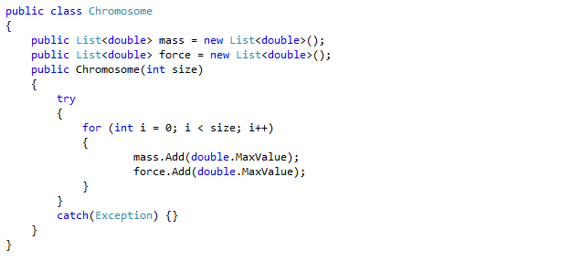

Here the chromosome has two members, the fuel capacity, represented as mass. And the force which is the engine horsepower. We are setting them to a sized list, and initializing them to the maximum value they can attain. This is because we will compare empty chromosomes to find out the best fit before we start doing the GA calculations.

The population is pretty much just a collection of the chromosomes used in the GA calculations. Here is the structure of the population 

**Genetic Computations**

I have enclosed all the GA computations inside an interface, to force implement all the functionalities of a GA in the class and also to follow a good programming design logic. Here is how the interface looks like: 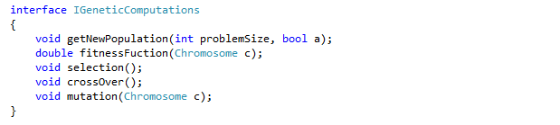

The methods defined are pretty obvious, but I will define each method’s functionality later.

The class that implements the functionality is like this. 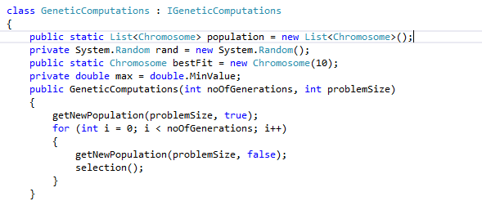

(Incomplete class, to be explained further)

**New population**

When we start, we need a set of population present for our calculations. The method defined below, will just generate a set of new population. To make this method hybrid, i.e. perform new population generation as well as perform genetic calculations if the population is already present is indicated through a Boolean variable passed as a parameter to the function. Another variable passed to the function is the size of the problem. This essentially implies the total number of the engines we will attach to the plane.

Here is the body of the function..

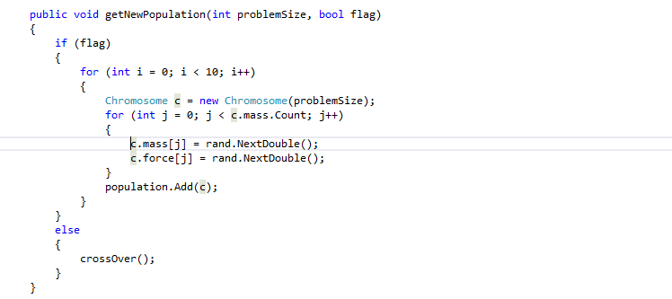

As you see above, the function will perform random assignment to generate the new population and will perform crossover is the population is already generated.

**Cross Over**

This is an important step in generating the new generation of population. Here we are to divide the chromosome at a point and perform a cross over between two chromosomes are this point. Here is a pictorial representation of cross over from wiki, which is self-explanatory.

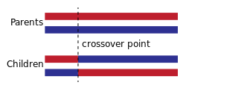

Here is the working of the crossover in the program, and how it is achieved in the above scenario. Please ignore the additional data structures used, they are for simplicity of understanding and not for optimization.

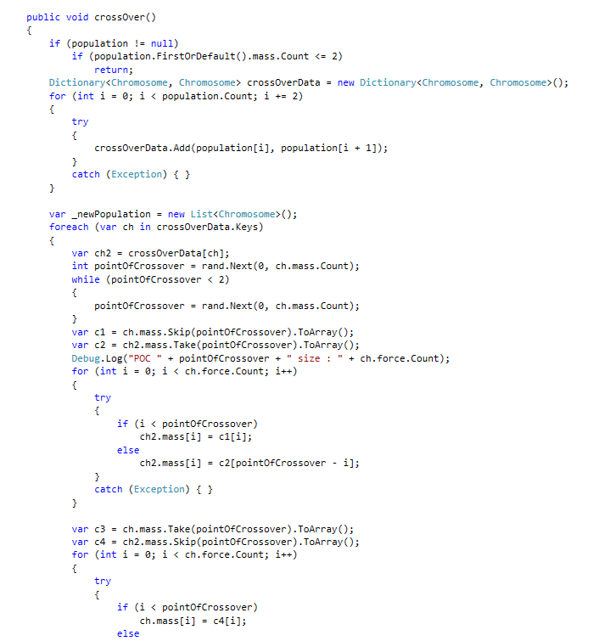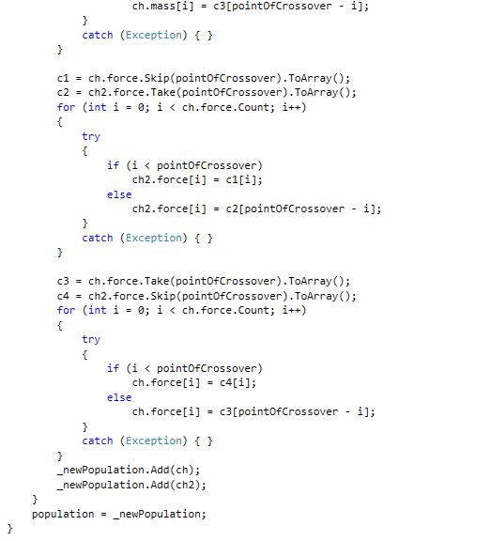

The above function only works if the chromosome size is more than 2. Which is an obvious requirement, to divide an array and swap its elements. We are performing the crossover for both force and mass. This makes our character, possibly, improve over time.

As important as crossover is, it doesn’t add new data to the chromosome population, just performs swapping of features within each parent inside the population. This is one of the shortcomings of the crossover modifications. We need more variety and diversity in the offspring to make our results more accurate over time. This is why we use Mutation.

**Mutation**

Mutation is a way to induce new genes into the chromosome to improve the chances of getting a better offspring. A new gene will depend on the given problem. However in most cases we take the array of the current chromosome data (which is the gene representation) and modify one of the values in the array to a new legal value. Legal implies a value that would make sense in the perspective of the problem. There are many types of mutations, based on how you are representing the values of the genes inside the chromosome. A simple bit mutation defined on wiki looks like this.

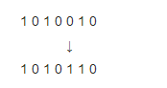

For our implementation we are inducing a new values inside a random point of the array, making it more suitable towards generating a better offspring.

Here is how we do it

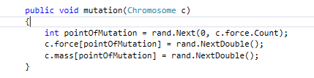

The above code is very simple and does mutation about a random point inside the gene. It is important to note, that incase of any gene, the total number of mass and force will always be the same inside any chromosome, as they are dependent on the total number of joints we have in the game.

**Fitness Function**

We have a lot of new chromosomes inside the population, now what? We need to determine which chromosome is the best for the given setting and how much it is good will be done by using it. A fitness function will evaluate a fitness of each chromosome inside the population and give us a good overview of which chromosomes are fit enough for a use, and also tell us which of these can be used for the next generation. We don’t want to be using incapable chromosomes as they will tend to divert us away from the right solution. A fitness function will also need a threshold, this will depend on the given situation and the consequences of using each chromosome, by trying them out practically just for the purpose of testing.

Coupled together with a selection function, that selects fit members of a population for further generations, here is how the fitness function looks for our situation.

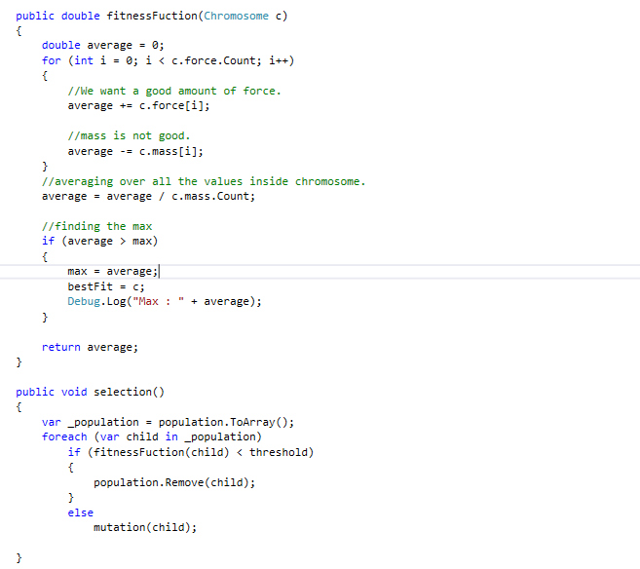

The above functions will remove the members below the threshold value of fitness. At the same time, they will calculate the new best chromosome that we can use from the selected population.

**How does the game work?**

This unity3d game revolves around mouse inputs. You start of by clicking in the world, where you would like to place the plane. As soon as you do that the GA comes into picture. You may now click near/on the plane, to add new engines. These engines are GA powered. These engines would now work on the principle of rigidbodies and HingeJoints. This will lead the velocity to be imparted on the plane as a whole too. Thus putting the plane in motion. You can move around the camera and look around to see if the plane actually reaches the end of the world, implying that it is fast enough to take off. This is essentially the function of the GA. As soon as the plane reaches one end of the world, the simulation resets. We are also providing a set of GUI controls to the user to modify his population and thus the execution of the GA. The plane model is taken from the internet, and is used only for educational purposes.

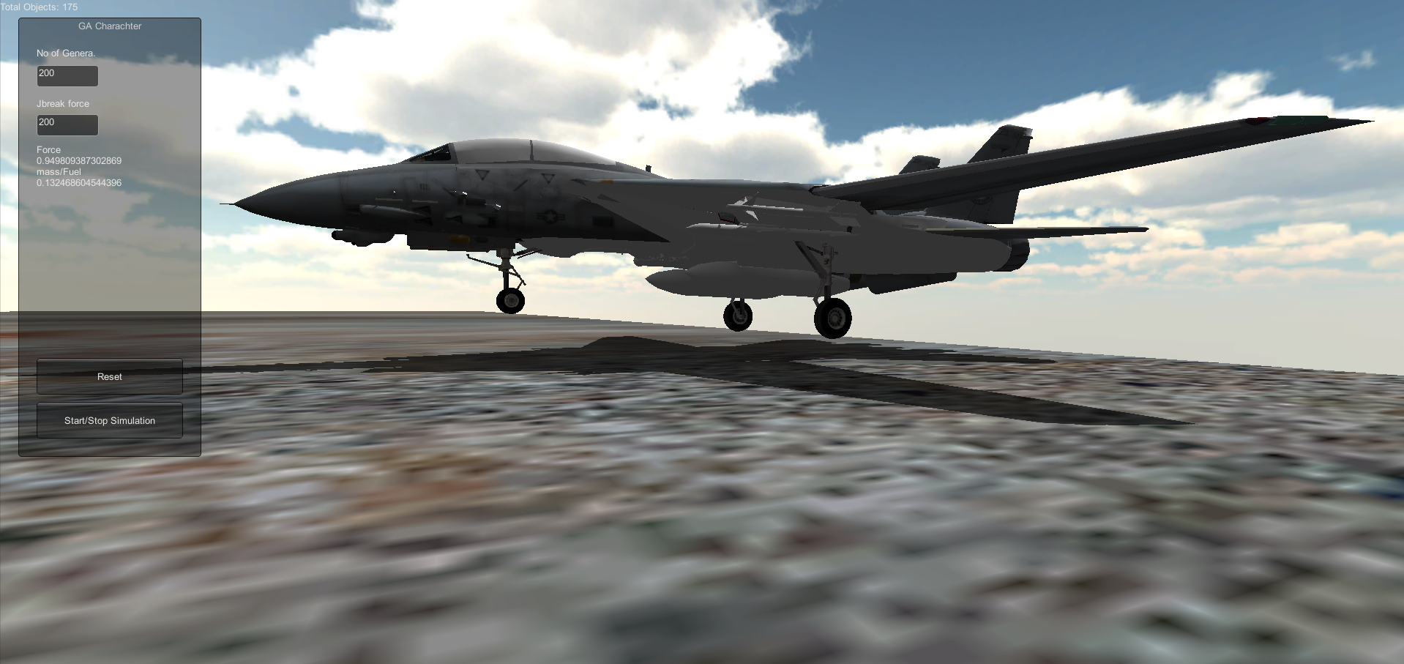

This is how the body looks. This is a state where we have the GA fired up, but not doing any work. Let us go ahead and modify the JBreak force (which implies the max joint break force) and the total generations for the simulation. On the GUI, we see some numerical data, which is just the dump of the GAs best possible fit for the current scenario. This is where we can see how the GA comes into picture. Attached below is another (zoomed) image to represent the body and the world. (Please see the next page)

The below image represents the engines attached at the rear end of the plane. You may use the start/stop simulation button to toggle the simulation of the body in the world.

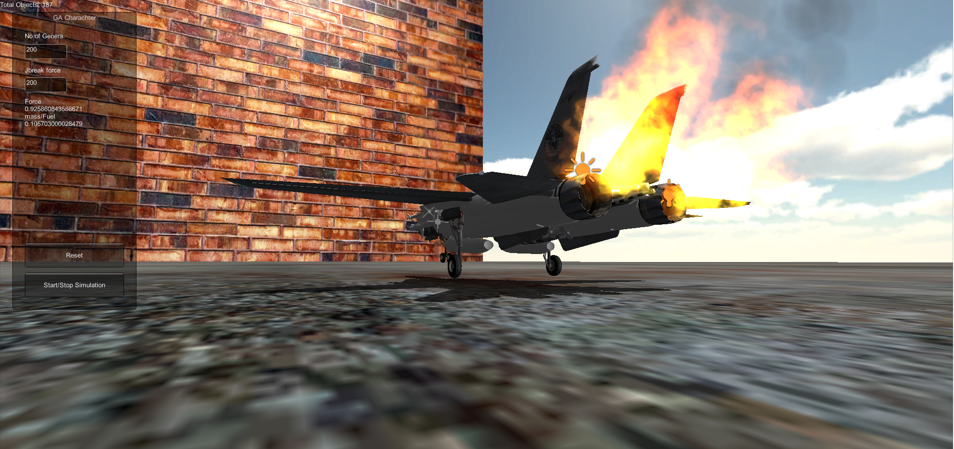

In the above world you may also use obstacles to make it more difficult for the body to make it to the end. This can be done by clicking the mouse on the intended position, which is slightly further away on the screen than the plane (else it will add engines).

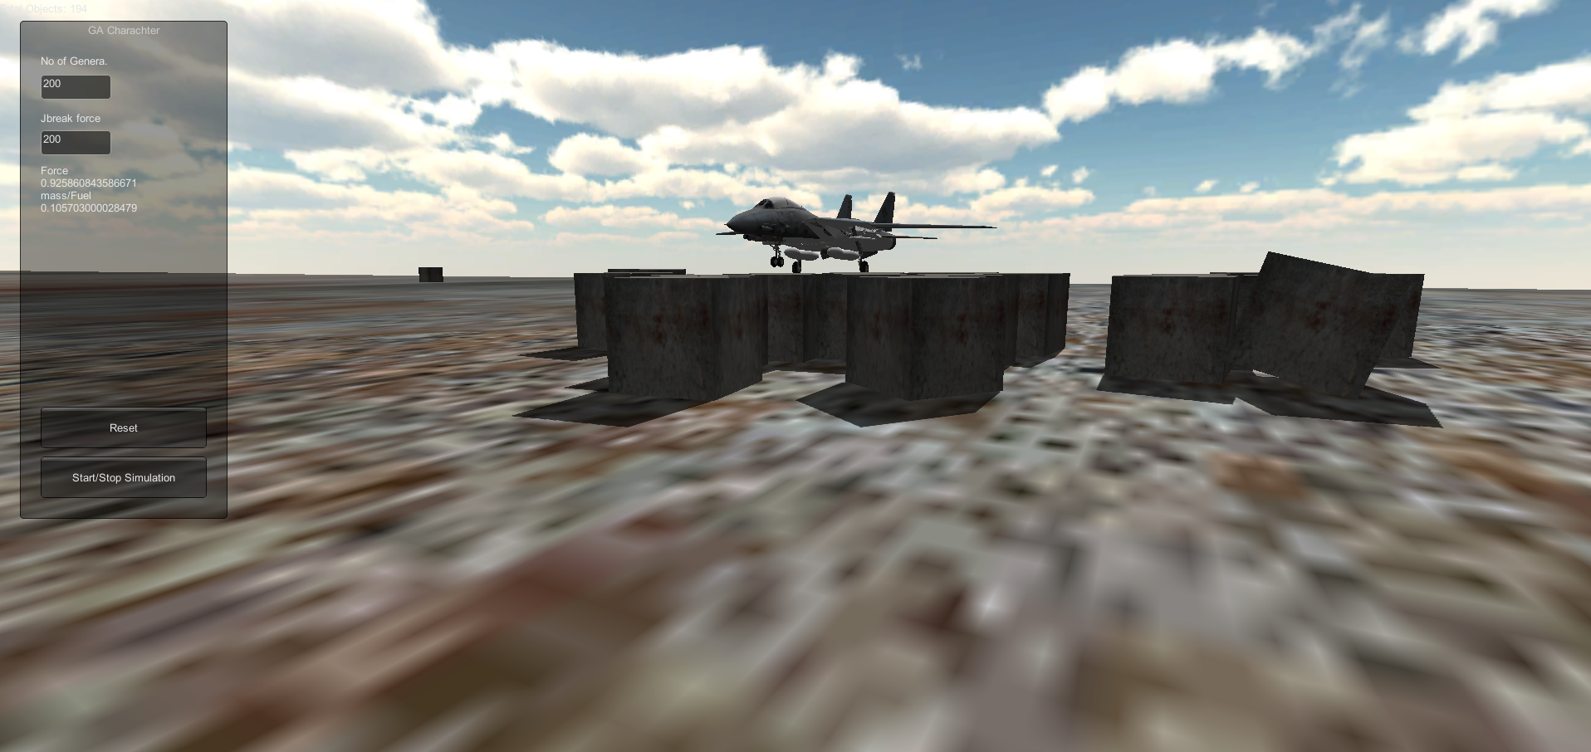

You can also select from the set of the obstacles available, if you have the source code access inside unity. You must note that the size or the scale remains constant though.

You may keep adding new engines to try and make the plane push through the world, however make sure you don’t overload the plane, and make it bulky. A bulky plane would remain stationary and look like this.

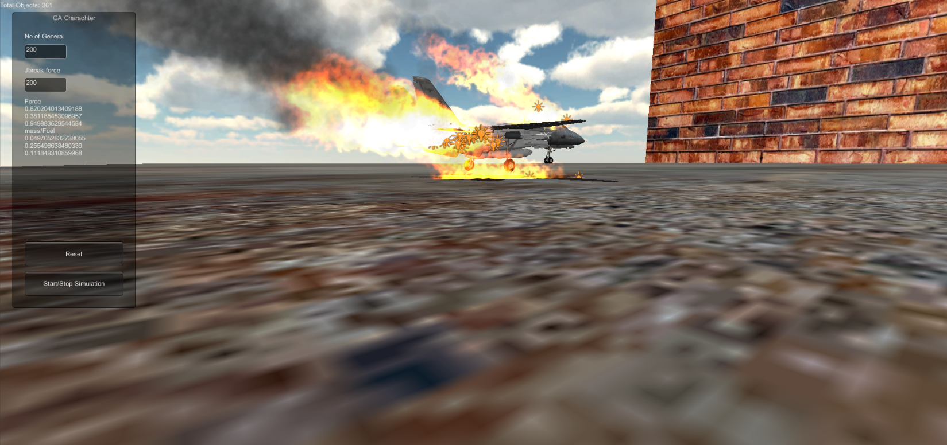

It also makes the plane look as if it’s burning! You went too far.